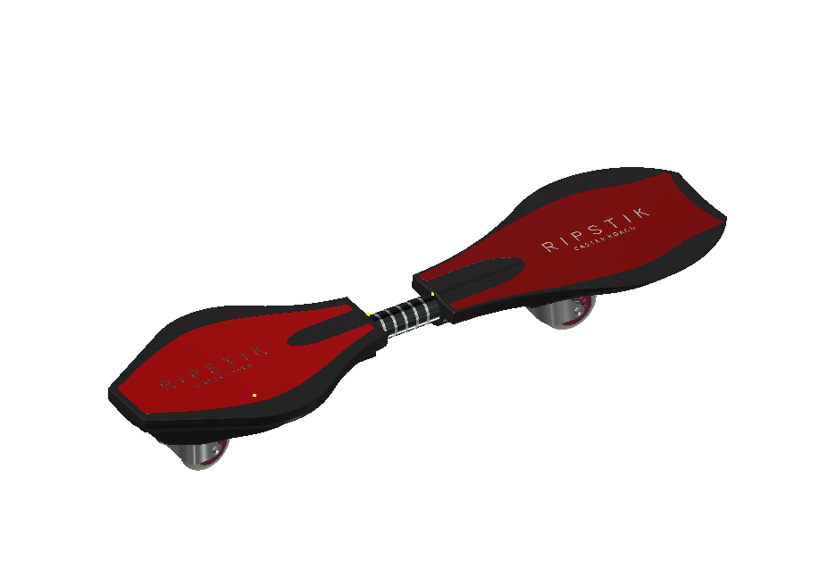

Ripstik

Cole Kiekow

IED Hr.2

Reverse Engineering